Coach Maureen Kane
Email: Maureenjk@gmail.com
Phone: 609-923-7794
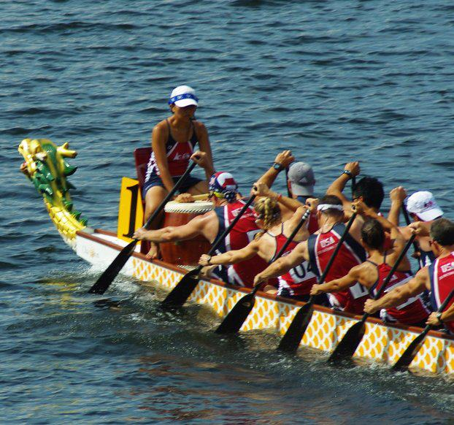
Conscientious, caring, motivating, energizing, determined, hardworking, reliable, knowledgeable and talented. These are just a few words used to describe Coach Maureen Kane.
Coach Maureen started her career as a dragon boat racer in 2005. She fell in love with the sport. The boats, people and the physical challenge drew her in. So much so that she set a goal to make the 2007 Team USA going to Australia. With hard work, determination and commitment to attending every practice and learning the sport, she made the team. Australia was her first of many national and international competitions. She went on to win a Gold Medal in the National Championships in 2008 at Long Beach, CA. Silver and Bronze World Medalist in Progue in 2009, Gold Medal winner and National Champion in 2010. Multiple Silver and Bronze Medalist in 2011 at the Tampa Bay International Dragon Boat Championship, Silver Medalist at the 2012 World Club Crew Championships in Hong Kong and finally Gold Medal winner and National Premier Champion in 2013.
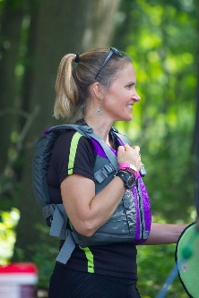
In 2012, she started her coaching career when she received her Personal Training Certification through NASM (National Association for Sports Medicine). She accepted the coaching position for the River Sirens and started her personal training internship at a progressive training facility, Evolution Fitness in Cherry Hill. Using the same determination that she did as a Dragon Boat Racer, Coach Maureen set out to learn to be the best coach she could be. From 2012 to 2018, she successfully trained and helped to build the River Sirens Team from a small recreational team to a major competitive club team made up of Sport and Community paddlers. With a new coaching staff in place, Coach Maureen stepped away from the River Sirens in 2019 to directly focus on her client training. After 7 dedicated years at Evolution Fitness, she decided to spread her wings. Coach Maureen is now working with clients privately online and in her home.
CERTIFICATIONS: NASM – Certified Personal Trainer, Corrective Exercise Specialist, Women’s Exercise Specialist, Youth Exercise Specialist. Certified Personal Trainer with NSCA - National Strength and Conditioning Association. Certified in CPR and AED through the American Red Cross. She completed the Competitive Dragon Boat Course in Canada presented by world renowned dragon boat coach Jim Farintosh in October of 2017.
Coach Maureen’s coaching style is cooperative. She expects the team members to do their homework, watch videos, ask questions and practice in front of the mirror at home. She expects the team members to become their best coach and push themselves aggressively. She also expects the team to work together. “Dragon Boat Racing is a team sport! Working together you will be stronger, better and faster than your competition.”

